

* 190521G RATHNAYAKE R.M.L.W.
* 190520D RATHNAYAKE R.M.K.L.
* 190060P ATHUKORALA K.H.
* 190144D DILSHAN J.V.A.P

**Project Proposal**

**Group 27**

March 2022

**Department of Electronic and Telecommunication Engineering University of Moratuwa**

EN 2110 – Electronics-III

**High Frequency Amplifier - Project Feasibility Report**

Pre Amplifier

INPUT

Power Amplifier

INPUT

## **Pre-Amplifier**

In an amplifier, the ‘signal amplifier’ does the initial amplification and the removal of noises, while the ‘Power Amplifier’ provides the final amplification, which needs to connect a load. There were different kinds of preamplifier designs.

**1.Pre-amplifier using BJT with common emitter configuration**

This method is also simple and common. As the first step, we thought to work with this configuration and adjust the circuit according to the upcoming problems.

### **DC bias**

The power supply is 12v and we have made the DC biasing point (Q point), such that VCE, Q is closer to 6v.

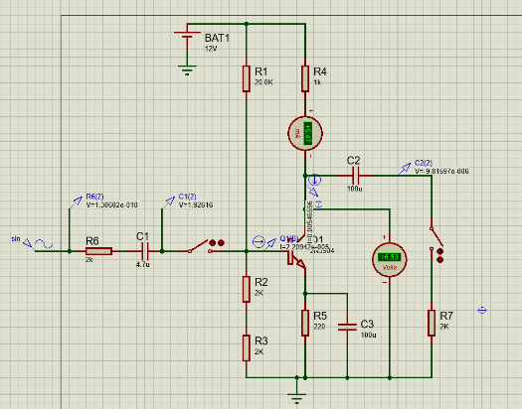

Figure 1

### **Amplification mode**

First, we have selected a sinusoidal waveform of 0.1v (peak to peak) with an initial frequency of 1kHz. We have first, analyzed the circuit without a load.

Figure 2:- Vin, Ib, Ic, Vo

### **Effect of load value**

After that, we have connected a load resistor of 2kohm.

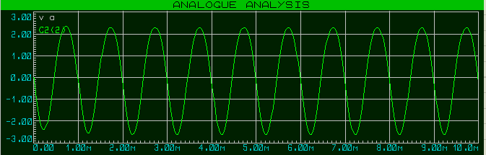

Figure 3: - Vo (Ro =2k, f=1kHz)

We have observed the fact that the output voltage has slightly dropped.

Then we reduced the output resistance to 100 ohms and observed the output current.

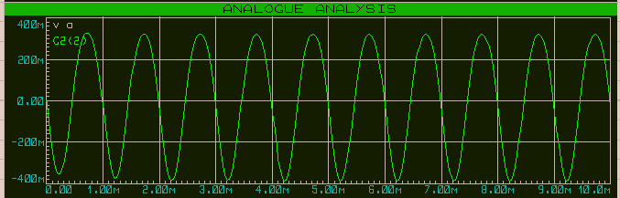

Figure 4: - Vo (Ro = 200ohm, f= 1kHz)

Conclusion: - When the load resistance has reduced, the output voltage has also reduced. We cannot expect this behavior, from a good amplifier.

### **Effect of frequency**

Then we have checked the effect of the frequency, by keeping the load of 200ohm and increasing the input frequency up to 1000kHz.

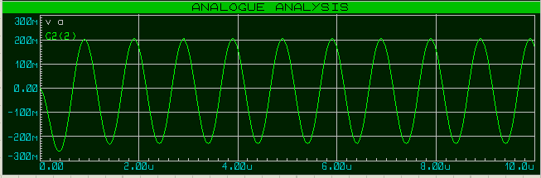

Figure5: - Vo (Ro = 200ohm, f= 1000kHz)

Conclusion: - When increasing the input frequency, the output voltage reduces (But the effect of frequency change is less than the effect of the change of load). A good amplifier should not have this behavior.

### **2.Pre-amplifier using 2 BJT transistors**

#### **(Alternative method)**

#### This is a simple, yet very useful pre-amplifier circuit. It draws little current from the load, due to its high input impedance. We hope to implement this, check its limits, and do the necessary changes to the circuit.

This pre-amplifier is said to be working properly, above the 3dB merging, in between the 20Hz to 200kHz.

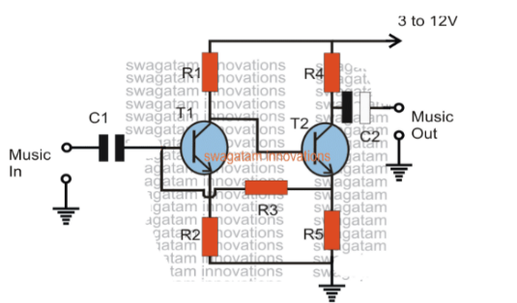

Figure 6

### **3.Pre-amplifier using FET**

#### **(Alternative method)**

This circuit can be implemented with only one JFET transistor. Therefore, this is much simpler than the previous model.

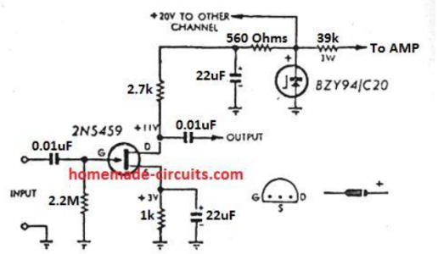

Figure 7

**Final Conclusion (Preamplifier): -**

We will need another amplification part to supply the corresponding current to the load and, keep the output voltage unchanged, even during a change of the load.

**Power-Amplifier**

This sort of amplification is using to amplify the power. This power will suit for resistance between 8 ohms and higher values. When we use Push pull amplifier output signal won’t get reduce its amplitude. Here one transistor is sinking current from the load to ground (or negative power supply) while the other transistor is supplying current to the load.

In push pull amplifier there are two outputs which are work in phase difference of 1800 .These two antiphase output signals are connected to load to add those output signals. But considering distortion parts of signals get subtracted due to their non-linearity. We can reduce distortion signals taking much similar non-linearity devices.

Mostly npn and pnp both types are using to design push pull amplification circuits. Which transistors to use for our project has to decide in future as we intend to select them depend on our stage 1 output. For now our intention is to use 4 transistors (2 pnp and 2npn transistors)

**Alternatives**

**Using Op Amps**

The circuit can be designed to convert the differential output current of an audio AC-DC converter into a single ended voltage capable of driving low impedance headphones. Two Op Amps are used as transimpedance amplifier which convert the DAC output current to a differential voltage. A difference amplifier then converts the differential voltage to single ended. A high power, high fidelity two channel audio Op Amp can be used in the difference amplifier to directly drive headphone loads.

**Transformer coupled class A amplifier circuit**

A transformer can be used to improves the efficiency of the amplifier by matching the impedance of the load with that of the amplifier output impedance.

**References**

1.Understanding, Calculating, and Measuring Total Harmonic Distortion

<https://www.allaboutcircuits.com/technical-articles/the-importance-of-total-harmonic-distortion/>

# 2. Amplifier Classes

<https://www.electronics-tutorials.ws/amplifier/amplifier-classes.html>

3.Data sheets.